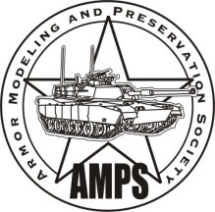
AMPS CENTEX
Austin Armor Builders Society

Model Expo Contest Summary Form (Page 2)
(For entrant with 11 or more entries ONLY)

Name |  |  | REGISTRATION #  (leave blank for contest  officials)
Entry Letters | Category | Entry Title |  | Scale
L
M
N
P
Q
R
S
T
U
V
W
X
Y
Z
25
26
27
28
29

AMPS CENTEX
Austin Armor Builders Society

Model Expo Contest Summary Form (Page 3)
(For entrant with 30 or more entries ONLY)

Name |  |  | REGISTRATION #  (leave blank for contest  officials)
Entry Letters | Category | Entry Title |  | Scale
30
31
32
33
34
35
36
37
38
39
40
41
42
43
44
45
46
47
48
49
50

