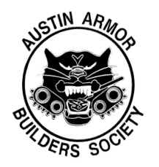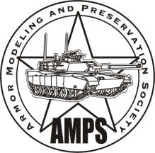**AMPS CENTEX**

**Austin Armor Builders Society**

**2021 Model Expo Contest Summary Form**

|  |  |  |  |  |  |
| --- | --- | --- | --- | --- | --- |
| *Name* | | | | **REGISTRATION #** *(leave blank for contest officials)* | |
| *Address* | | | |  | |
|  | | | | *Phone #* | |
| *City* | | | | *E-mail* | |
| *State* | | | *Zip Code* |  | |
| *Skill Level (Check one ONLY)* | | | |  | |
| *Entry Letter* | *Category* | *Entry Title* | | | *Scale* |
| A |  |  | | |  |
| B |  |  | | |  |
| C |  |  | | |  |
| D |  |  | | |  |
| E |  |  | | |  |
| F |  |  | | |  |
| G |  |  | | |  |
| H |  |  | | |  |
| J |  |  | | |  |
| K |  |  | | |  |

*Entrant with 11 or more entries please continue on Summary Form page 2 (or 3).*